**Monolithic Architecture:**

Monolithic architecture is a traditional software development style where an application is built as a single, indivisible unit. This means all components, such as the user interface, business logic, and data access layers, are interconnected and interdependent within a single codebase.

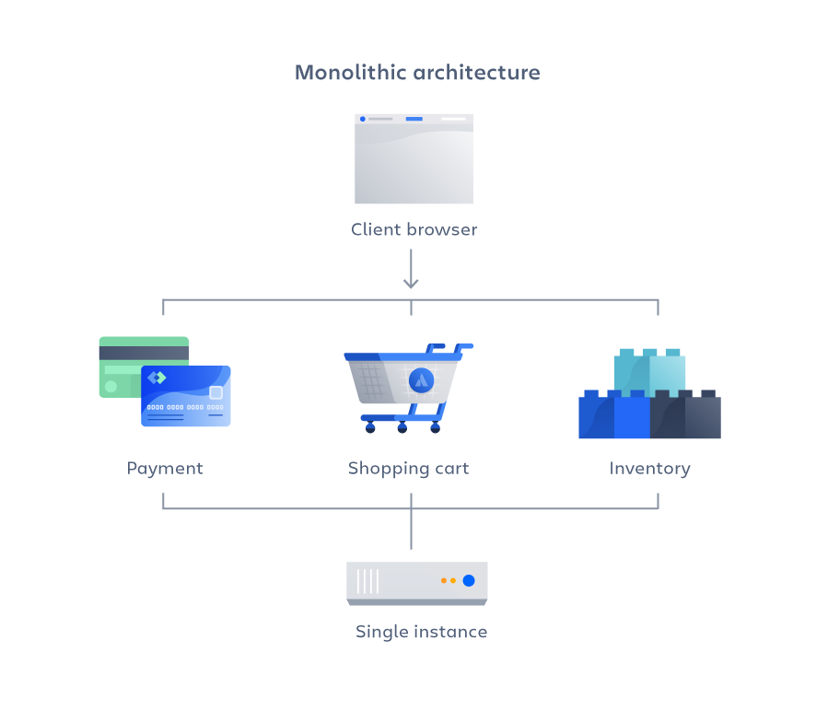

* **Example:**
* **Let's say you're developing a blog platform. In a monolithic architecture, your application might have the following structure:**
  + **UI Layer:** Handles user interactions, displaying blog posts, user authentication, and comments.
  + **Business Logic Layer:** Manages post creation, editing, and deletion; handles user roles and permissions.
  + **Data Access Layer:** Manages data storage and retrieval from the database for posts, users, and comments.

All these layers are part of a single codebase and are deployed as one unit. When you need to update the application (e.g., adding a new feature like post tags), you update codebase and redeploy the entire application.

* **Consider a simple e-commerce application. In a monolithic architecture, the application would consist of:**
  + **User Interface:** Manages user interactions, displays product listings, handles user authentication.
  + **Business Logic:** Processes user requests, manages inventory, processes orders and payments.
  + **Database Access:** Handles data retrieval and storage for products, users, and orders.

All these components are packaged together and deployed as a single unit. When you update one part of the application, you redeploy the entire application.

* **Characteristics:** 
  + **Single Codebase:** All functionality is contained within one codebase and deployed together.
  + **Single Deployment:** The entire application is deployed as a single unit.
  + **Tightly Coupled Component:** Components are interconnected and interdependent.
  + **Shared Memory:** Components often share the same memory space and data stores.
  + **Unified Management:** Easier to manage in terms of deployment, monitoring, and scaling as a single entity.
* **Importance:**

Monolithic architecture is important for its simplicity and straightforward approach to building applications, especially when:

* Teams are small and resources are limited.
* The application is relatively simple and does not require significant scaling.
* Rapid development and deployment are essential.
* **Benefits:** 
  + **Simple Development:** Easier to develop and manage for small teams.
  + **Easier Testing:** Testing can be straightforward since all components are within a single unit.
  + **Performance:** Can be efficient due to shared memory and reduced overhead from inter-process communication.
  + **Simplified Deployment:** Single deployment artifact simplifies the deployment process.
  + **Consistency:** All components are within a single codebase, making it easier to maintain consistency in coding standards and practices.
* **Drawbacks:**
  + **Scalability:** Difficult to scale specific parts of the application independently.
  + **Complexity Over Time:** As the application grows, codebase can become large and difficult to manage.
  + **Deployment Risk:** Changes to any part of the application require redeploying the entire application, increasing the risk of downtime.
  + **Limited Flexibility:** Tightly coupled components make it harder to adopt new technologies incrementally.
  + **Maintenance:** Harder to maintain and debug as the application grows.
* **When to Use Monolithic Architecture:**
  + **Small to Medium-Sized Applications:** Suitable for smaller applications where complexity and scalability are not major concerns.
  + **Startups and MVPs:** Ideal for startups and Minimum Viable Products (MVPs) where speed of development and simplicity are more critical.
  + **Tightly Integrated Components:** When components are tightly integrated and benefit from shared memory and resources.
  + **Limited Resources:** When the development team and resources are limited, making the simplicity of monolithic architecture advantageous
  + **Stable Applications:** For applications that are relatively stable and do not require frequent updates or scaling.

Monolithic architecture is a straightforward approach that is suitable for certain types of applications, especially those that are simple, stable, or in early development stages. While it offers simplicity and ease of development, it can become a burden as the application grows in complexity and scale. Understanding its benefits and drawbacks helps in making informed decisions about when to use monolithic architecture versus other architectural styles, such as microservices.

**Microservices Architecture:**

Microservices architecture is an architectural style that structures and application as a collection of loosely coupled, independently deployable services. Each service in a microservices architecture is designed to perform a specific business function and can be developed, deployed, and scaled independently of the other services.

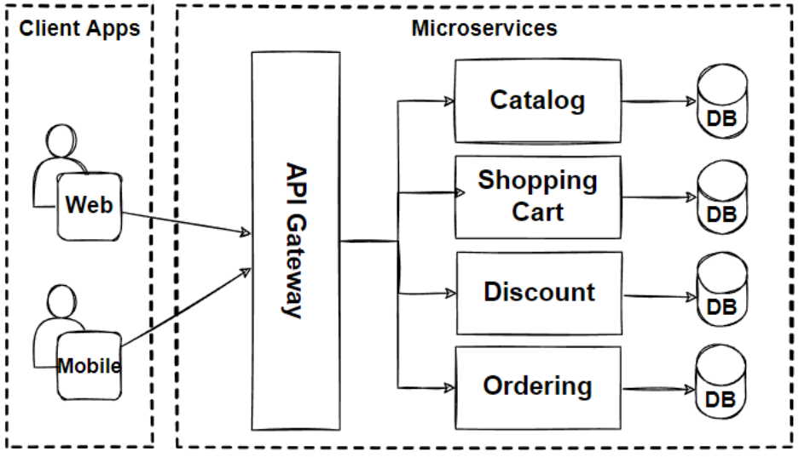

* **Example:**

Consider an e-commerce platform, which might have the following services in a microservices architecture:

1. **User Service:** Manages user registration, login, profiles, and authentication.
2. **Product Service:** Handles product catalog, including adding, updating, and retrieving product details.
3. **Order Service:** Manages customer orders, including order creation, status tracking, and history.
4. **Payment Service:** Handles payment processing, including transactions, refunds, and payment history.
5. **Notification Service:** Sends notifications via email, SMS, or push notifications for order status, promotions, etc.

Each of these services can be developed, deployed, and scaled independently. For example, if the payment service needs to handle more transactions, it can be scaled without affecting the other services.

* **Characteristics:** 
  + **Independent Deployment:** Each microservices can be deployed without affecting other services.
  + **Loosely Coupled:** Services are independent of each other, reducing dependencies.
  + **Specialized:** Each service focuses on a specific business capability.
  + **Technology Diversity:** Different services can use different tech stacks best suited to their needs.
  + **Scalability:** Individual services can be scaled independently based on demand.
* **Importance:**
  + **Flexibility:** Allows teams to choose the best technologies for each service.
  + **Agility:** Facilitates faster development and deployment cycles.
  + **Resilience:** Failure in one service does not necessarily affect others.
  + **Scalability:** Better resource utilization by scaling only the services that need it.
  + **Maintainability:** Easier to understand, develop, and manage smaller codebases.
* **Benefits:**
  + **Improved Scalability:** Scale services independently based on demand.
  + **Enhanced Development Speed:** Different teams can work on different services simultaneously.
  + **Fault Isolation:** Issues in one service are less likely to impact the entire system.
  + **Technology Heterogeneity:** Use different technologies suited to specific services.
  + **Continuous Deployment:** Easier to deploy updates to individual services without downtime.
* **Drawbacks:**
  + **Complexity:** Increased complexity in managing multiple services.
  + **Communication Overhead:** Services need to communicate over the network, introducing latency.
  + **Data Consistency:** Managing data consistency across services can be challenging.
  + **Deployment:** Requires sophisticated deployment and monitoring infrastructure.
  + **Testing:** More complex integration and end-to-end testing.
* **When to Use Microservices Architecture:** 
  + **Complex Application:** Suitable for large, complex applications with multiple functionalities.
  + **Scalability Needs:** When different parts of the application have varying scalability requirements.
  + **Frequent Updates:** Ideal for applications that need frequent and independent updates.
  + **Agile Development:** Supports agile development methodologies and continuous integration/continuous deployment (**CI/CD**).
  + **Distributed Teams:** Suitable for organizations with distributed development teams working on different parts of the application.
* **Communication and Coordination:**

Microservices communicate over the network, typically using RESTful APIs, messaging queues (e.g., Kafka), or RPC (Remote Procedure Call) protocols like gRPC. For instance, when a user places an order:

1. **Order Service** creates the order and sends an event/message to the Payment Service.
2. **Payment Service** processes the payment and updates the Order Service with the payment status.
3. **Order Service** updates the order status and sends a notification request to the Notification Service
4. **Notification Service** sends a confirmation email/SMS to the user.

* **Deployment:**

Each microservices is packaged and deployed independently. Tools like Docker and Kubernetes are commonly used to manage containerized services and orchestrate their deployment, scaling, and operation.

Microservices architecture is a modern approach to building applications that require flexibility, scalability, and resilience. By breaking down an application into smaller, manageable services, organizations can develop, deploy, and scale different parts of the application independently, leading to improved agility and efficiency. However, this approach also introduces complexity in terms of management, communication, and data consistency, which needs to be carefully managed.

**Communication in Microservices Architecture:**

In a microservices architecture, multiple services communicate with each other to achieve the overall functionality of the application.

* **This communication can happen through several methods:**
  1. **RESTful API:** Services communicate over HTTP using standard REST protocols.
  2. **Messaging Queues:** Asynchronous communication using message brokers like RabbitMQ, Kafka, or ActiveMQ.
  3. **Remote Procedure Calls (RPC):** Synchronous communication using protocols like gRPC.
  4. **Event-Driven Architecture:** Services publish events and other services subscribe to those events.
* **Example: E-Commerce Platform:**
* **Scenario:** Consider an e-commerce platform with the following services:
  + **User Service:** Manages user registration, login, and profile.
  + **Product Service:** Manages product catalog.
  + **Order Service:** Manages customer orders.
  + **Payment Service:** Processes payments.
  + **Notification Service:** Sends notifications.
* **Communication Between Services:**
  1. **RESTful APIs:**
     + **Order Service** calls **User Service** to retrieve user details.
     + **Order Service** calls **Product Service** to check product availability.
  2. **Messaging Queues:** 
     + **Order Service** sends a message to a queue when an order is placed.
     + **Payment Service** listens to the queue for new order messages and processes the payment.
     + **Notification Service** listens to the queue for payment success messages and sends a notification to the user.
  3. **Event-Driven Architecture:** 
     + **Payment Service** publishes an event when a payment is successful.
     + **Order Service** subscribes to the payment success event to update the order status.

**Designing Microservices Architecture: Real-World Example:**

* **Step-by-Step Design**

1. **Identity Services:** 
   * Analyze the application requirements and identify distinct business capabilities.
   * Each capability is a potential candidate for a microservices.

**For our E-Commerce Application:**

* **User Service:** User management.
* **Product Service:** Product catalog management.
* **Order Service:** Order processing.
* **Payment Service:** Payment processing.
* **Notification Service:** Sending notifications.

1. **Define Service Boundaries:** 
   * Clearly define the responsibilities and boundaries of each service.
   * Ensure minimal overlap and tight cohesion within services.
2. **Choose Communication Methods:** 
   * Decide on the communication protocols based on the use case.
   * Synchronous communication (REST, RPC) for real-time interactions.
   * Asynchronous communication (messaging queues, events) for decoupled processing.
3. **Design APIs:** 
   * Define the APIs for each service, specifying the endpoints, request/response formats, and protocols.
   * Use OpenAPI/Swagger for API documentation.

* **User Service API:**
  + **‘/register/’:** Registers a new user.
  + **‘/login/’:** Authenticates a user.
  + **‘/profile/{userId}’:** Retrieves user profile.
* **Product Service API:** 
  + **‘/products’:** Retrieves all products.
  + **‘/products/{productId}’:** Retrieves a specific product.
  + **‘/products/category/{category}’:** Retrieves products by category.
* **Order Service API:** 
  + **‘/orders’:** Creates a new order.
  + **‘/orders/{orderId}’:** Retrieves order details.
  + **‘/order/user/{userId}’:** Retrieves orders for a user.
* **Payment Service API:** 
  + **‘/pay’:** Processes a payment.
  + **‘/refund’:** Processes a refund.
  + **‘/transactions/{transactionId}’:** Retrieves transaction details.
* **Notification Service API:**
  + **‘/notify/email’:** Sends an email notification.
  + **‘/notify/sms’:** Sends an SMS notification.

1. **Database Design:** 
   * Use separate databases for each service to ensure loose coupling.
   * Shared databases can lead to tight coupling and coordination challenges.
   * **User Service DB:** User table: user_id, name, email, password, etc.
   * **Product Service DB:** Product table: product_id, name, category, price, stock, etc.
   * **Order Service DB:** Order table: order_id, user_id, product_id, quantity, status, etc.
   * **Payment Service DB:** Transaction table: transaction_id, order_id, amount, status, etc.
   * **Notification Service DB:** Log table: notification_id, user_id, message, status, etc.
2. **Event Handling:** 
   * Design event producers and consumers for asynchronous communication.
   * Use event brokers like Kafka or RabbitMQ.
   * **Order Service:** Publishes "OrderPlaced" event.
   * **Payment Service:** 
     1. Consumes "OrderPlaced" event.
     2. Publishes "PaymentProcessed" event.
   * **Notification Service:** Consumes "PaymentProcessed" event to send notifications.
3. **Deployment Strategy:** 
   * Use containerization (**Docker**) for each service.
   * Use orchestration tools (**Kubernetes**) for managing containers.
   * Define deployment pipelines (CI/CD) for automated deployment.
4. **Monitoring and Logging:**
   * Implement centralized logging and monitoring for all services.
   * Use tools like ELK stack (Elasticsearch, Logstash, and Kibana), Prometheus, and Grafana.

* **Real-World Example: Detailed Interaction**

**User Registration and Order Placement**

1. **User Registration:** 
   * **User Service** provides an endpoint **‘/register’** to register new users.
   * The frontend calls this endpoint with user details.
   * **User Service** stores the user information in its database and returns a success response.
2. **Product Browsing:** 
   * The frontend calls the **Product Service** endpoint /products to retrieve the product catalog.
   * **Product Service** queries its database and returns the list of products.
3. **Order Placement:** 
   * The user selects products and places an order.
   * The frontend calls the **Order Service** endpoint **‘/orders’** with order details.
   * **Order Service** verifies product availability by calling **Product Service.**
   * **Order Service** creates a new order in its database and publishes an "OrderPlaced" event to a messaging queue.
4. **Payment Processing:** 
   * **Payment Service** listens to the messaging queue and processes the payment for the new order.
   * On successful payment, **Payment Service** updates its database and publishes a "PaymentProcessed" event.
5. **Notification:** 
   * **Notification Service** listens to the "PaymentProcessed" event and sends a confirmation email/SMS to the user.
   * **Notification Service** logs the notification status in its database.

Microservices architecture provides a flexible, scalable, and resilient way to design modern applications by breaking down a large application into smaller, manageable services. Each service focuses on a specific business capability and can be developed, deployed, and scaled independently. Effective communication between services, robust API design, proper database segregation, and efficient event handling are crucial for a successful microservices implementation. Using containerization and orchestration tools ensures smooth deployment and management of services, while centralized logging and monitoring help maintain the overall health and performance of the application.

**API:**

**API (Application Programming Interface)** is a set of rules and protocols that allows one software application to interact with another. APIs define the methods and data formats that applications can use to communicate with each other, abstracting the underlying implementation details. They are critical in enabling different software systems to work together, share data, and extend functionalities.

* **Where are APIs used in Microservices:**

In microservices architecture, APIs are crucial for inter-service communication and integration. Here's how and why APIs are used:

1. **Service Communication:** 
   * **RESTful APIs:** Commonly used for synchronous communication between microservices over HTTP.
   * **gRPC APIs:** Used for more efficient binary communication, often in high-performance or low-latency scenarios.
2. **Service Integration:** APIs enable integration with third-party services, external APIs, and legacy systems.
3. **Service Composition:** Microservices often need to call APIs of other Microservices to compose a larger business workflow.
4. **Decoupling:** APIs abstract the implementation details of a microservices, allowing teams to work independently and deploy changes without affecting other services.

* **Differentiating APIs and Microservices:** 
  + **Definition:** 
    - **API:** A set of rules and protocols for building and interacting with software applications.
    - **Microservices:** An architectural style that structures an application as a collection of loosely coupled services, each implementing a specific business function.
  + **Purpose:** 
    - **API:** Facilitates communication and data exchange between different software components.
    - **Microservices:** Decomposes an application into smaller, manageable, and independently deployable services.
  + **Scope:** 
    - **API:** Can exist in any type of software architecture (monolithic, SOA, microservices).
    - **Microservices:** Refers specifically to an architectural style.
  + **Usages:** 
    - **API:** Used to expose functionalities and allow interaction between components or systems.
    - **Microservices:** Defines the entire architecture and operational model of the application.
  + **Granularity:** 
    - **API:** Represents specific interfaces for specific functionalities (e.g., user management, product catalog).
    - **Microservices:** Represents an entire service, which might expose multiple APIs.

APIs are the glue that binds microservices together, enabling them to communicate, share data, and orchestrate business workflows. While APIs provide the interfaces for communication, microservices define the architecture in which these interfaces operate. Understanding the distinction and interdependence between APIs and microservices is crucial for designing, implementing, and managing modern, distributed applications.

**HTTP Methods:**

HTTP (Hypertext Transfer Protocol) methods are standardized request types used by web clients (such as browsers or APIs) to interact with web servers. Each method performs a different type of operation. Here are the main HTTP methods, explained with examples:

* **GET:** Retrieve data from a server.
* **POST:** Send data to a server to create a new resource.
* **PUT:** Update an existing resource or create a new resource if it doesn't exist.
* **DELETE:** Remove a resource from the server.
* **PATCH:** Apply partial modifications to a resource.
* **HEAD:** Retrieve headers from the server response, without the body.
* **OPTIONS:** Describe the communication options for the target resource.
* **CONNECT:** Establish a tunnel to the server.
* **TRACE:** Perform a message loop-back test along the path to the target resource.

These methods are fundamental to **RESTful** **APIs** and are used to manage the lifecycle of resources in a web service. Understanding their use and behavior is crucial for designing and interacting with web APIs.

**Principal behind Microservices:**

Microservices architecture is designed to break down a large monolithic application into smaller, more manageable services, each of which is responsible for a specific business function. This approach provides several benefits, including scalability, flexibility, and resilience. Here are the key principles behind microservices, explained in detail with examples.

* **Independent and Autonomous Service:**
  + **Principal:** Each microservice operates independently and is autonomous, meaning it encapsulates a specific business functionality and can be developed, deployed, and scaled independently.
  + **Example:** In an e-commerce platform, different microservices can handle user management, product catalog, order processing, and payment processing. These services operate independently, so updating the user management service does not require changes to the payment processing service.
* **Scalability:** 
  + **Principal:** Microservices can be scaled independently based on demand, allowing better resource utilization and performance optimization.
  + **Example:** During a sales event, the order processing and payment processing services might need to handle a higher load. These services can be scaled up to manage the increased traffic without affecting other services like the user management or product catalog.
* **Decentralization:** 
  + **Principal:** Microservices encourage decentralized governance and data management, allowing each team to choose the best technology and tools for their specific service.
  + **Example:** The product catalog service might use a NoSQL database for flexibility, while the order processing service might use a relational database for transactional integrity. Each team can decide the most suitable technology stack for their service.
* **Resilience Service:** 
  + **Principal:** Microservices are designed to be resilient, meaning they can handle failures gracefully and continue to operate, ensuring overall system stability.
  + **Example:** If the payment processing service fails, the order processing service can still continue to process new orders and queue them for payment once the payment service is restored. Circuit breakers and retries are common patterns used to build resilient services.
* **Real Time Load Balancing:** 
  + **Principal:** Microservices architecture supports real-time load balancing to distribute incoming traffic evenly across multiple instances of a service.
  + **Example:** A load balancer can distribute incoming requests to the order processing service across multiple instances, ensuring no single instance is overwhelmed and improving overall performance and availability.
* **Availability:** 
  + **Principal:** Microservices architecture enhances availability by enabling redundant service instances and distributing them across different servers or data centers.
  + **Example:** Multiple instances of the user management service can be deployed across different availability zones or regions, ensuring that even if one zone or region goes down, the service remains available to users.
* **Continuous Delivery through DevOps Integration:** 
  + **Principal:** Microservices facilitate continuous delivery and integration, allowing rapid deployment of new features and updates through automated CI/CD pipelines.
  + **Example:** A development team can use a CI/CD pipeline to automatically test, build, and deploy updates to the product catalog service. This pipeline ensures that new features are quickly released without disrupting other services.
* **Seamless API Integration and Continuous Monitoring:** 
  + **Principal:** Microservices communicate via APIs, enabling seamless integration. Continuous monitoring ensures each service's health and performance are tracked and issues are detected early.
  + **Example:** The order processing service might call the payment processing service's API to process payments. Tools like Prometheus and Grafana can be used to monitor metrics and logs from each microservice, providing insights into performance and operational issues.
* **Isolation from Failures:** 
  + **Principal:** Microservices are designed to isolate failures, preventing a failure in one service from cascading to others.
  + **Example:** If the product catalog service fails, it should not impact the user management or order processing services. This isolation ensures that the system remains operational even when individual services encounter issues.
* **Auto-Provisioning:** 
  + **Principal:** Microservices architecture supports auto-provisioning, allowing automatic scaling and deployment of services based on demand.
  + **Example:** Auto-scaling policies can be set up for the order processing service to automatically add more instances when the incoming request rate exceeds a certain threshold. This ensures the service can handle peak loads without manual intervention.
* **Example: E-Commerce Platform**

Let’s consider an e-commerce platform to see these principles in action:

1. **Independent and Autonomous Services:** 
   * **User Service:** Manages user registrations, logins, and profiles.
   * **Product Service:** Manages product information and inventory.
   * **Order Service:** Manages order placement and tracking.
   * **Payment Service:** Handles payment processing.
2. **Scalability:** During Black Friday sales, the **Order Service** and **Payment Service** can be scaled up independently to handle the increased load.
3. **Decentralization:** The **Product Service** team uses MongoDB for flexible product data, while the **Order Service** team uses PostgreSQL for transactional consistency.
4. **Resilient Service:** The **Order Service** uses circuit breakers to gracefully handle failures in the **Payment Service**, retrying payments after a delay.
5. **Real-Time Load Balancing:** A load balancer distributes incoming requests to the **Order Service** across multiple instances to ensure no single instance is overwhelmed.
6. **Availability:** Multiple instances of the **User Service** are deployed across different regions to ensure high availability even if one region fails.
7. **Continuous Delivery through DevOps Integration:** The **Product Service** team uses a CI/CD pipeline to deploy new features and updates automatically, ensuring quick and reliable releases.
8. **Seamless API Integration and Continuous Monitoring:** The **Order Service** calls the **Payment Service** API to process payments. Monitoring tools track the performance and health of each service, alerting teams to issues.
9. **Isolation and Failures:** If the **Product Service** experiences an outage, users can still log in, place orders, and process payments without disruption.
10. **Auto-Provisioning:** Kubernetes auto-scaling policies automatically add instances to the **Order Service** when incoming requests increase, ensuring the service can handle peak loads.

Microservices architecture promotes building scalable, resilient, and flexible applications by decomposing them into smaller, independent services. Each principle enhances specific aspects of system design and operation, ensuring that applications can evolve, scale, and withstand failures effectively. Understanding and implementing these principles can significantly improve the reliability and performance of modern software systems.

**Microservices Design Pattern:**

Microservices architecture involves various design patterns to solve common challenges and ensure the system remains scalable, resilient, and maintainable. Here are some key microservices design patterns explained in detail with examples:

* **Aggregator:** 
  + **Principal:** The Aggregator pattern is used to gather data from multiple services and aggregate it into a single response. This pattern helps in reducing the number of calls from clients to backend services.
  + **Example:** In an e-commerce platform, the homepage may need data from user service (user details), product service (featured products), and order service (recent orders). An aggregator service can call these services, collect the necessary data, and return a single response to the client.

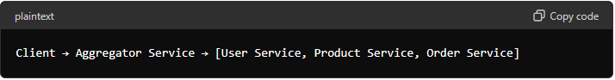

* **API Gateway:** 
  + **Principal:** The API Gateway pattern provides a single entry point for all client requests, routing them to appropriate microservices. It can handle tasks such as authentication, load balancing, caching, and request transformation.
  + **Example:** A mobile app for the e-commerce platform makes a single request to the API Gateway, which then routes the request to the appropriate microservices like user service, product service, or order service.

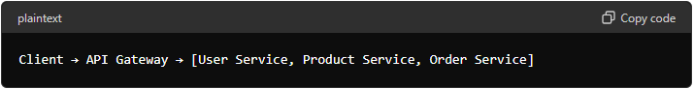

* **Chained or Chained of Responsibility:** 
  + **Principal:** The Chain of Responsibility pattern involves multiple microservices processing a request in a sequence, where each service performs a part of the task and passes the request to the next service.
  + **Example:** In an order processing system, the request to place an order goes through inventory service (to check stock), payment service (to process payment), and shipping service (to arrange delivery) in a chain.

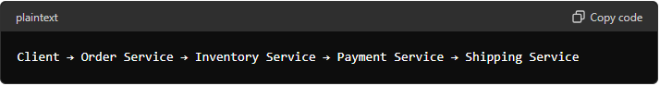

* **Asynchronous Messaging:** 
  + **Principal:** The Asynchronous Messaging pattern uses message queues or message brokers to enable microservices to communicate without waiting for responses, ensuring loose coupling and resilience.
  + **Example:** When a new order is placed, the order service publishes an order event to a message queue. Other services like inventory, payment, and shipping consume the message and process the order asynchronously.

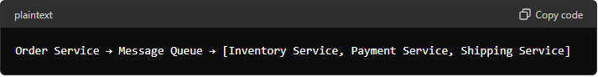

* **Database Design Patterns or Distributed Database Design Patterns:**
  + **Principal:** These patterns deal with how data is stored and managed across multiple databases in a microservices architecture.
    - **Database per Service:** Each microservice has its own database, ensuring data isolation and independence.
      * **Example:** User service uses a PostgreSQL database, product service uses MongoDB, and order service uses MySQL.
    - **Shared Database:** Multiple microservices share a single database, often used when strong consistency is needed.
      * **Example:** Both order and payment services access a shared transactional database.



* **Event Sourcing:** 
  + **Principal:** The Event Sourcing pattern ensures that all changes to the application state are stored as a sequence of events. This pattern allows for reconstruction of past states and auditability.
  + **Example:** In a banking system, instead of storing the current account balance, all deposit and withdrawal events are stored. The current balance can be derived by replaying these events.

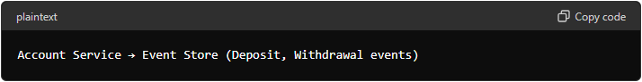

* **Command Query Responsibility Segregator (CQRS):** 
  + **Principal:** CQRS separates the read and write operations into different models to optimize performance, scalability, and security.
  + **Example:** In a customer management system, the write model handles commands like **‘CreateCustomer’**, **‘UpdateCustomer’**, while the read model handles queries like **‘GetCustomerDetails’**.

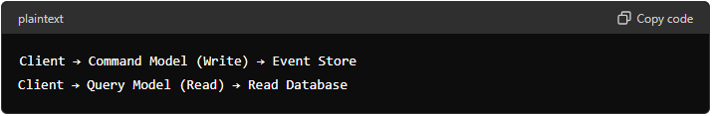

* **Circuit Breaker Patterns:** 
  + **Principal:** The Circuit Breaker pattern prevents a service from repeatedly trying to execute an operation that is likely to fail, thus avoiding cascading failures.
  + **Example:** If the payment service is down, the order service stops calling it after a certain number of failures, and returns an error immediately, ensuring the system remains responsive.

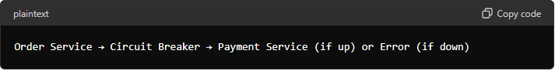

* **Decomposition Design Pattern:** 
  + **Principal:** Decomposition patterns help in breaking down a monolithic application into microservices.
    - **Decompose by Business Capability:** Split the system based on business capabilities.
      * **Example:** An e-commerce platform can be decomposed into user management, product catalog, order processing, and payment processing services.
    - **Decompose by Subdomain:** Decompose the system based on subdomains of the business.
      * **Example:** A banking system can be split into subdomains like accounts, loans, and customer service.

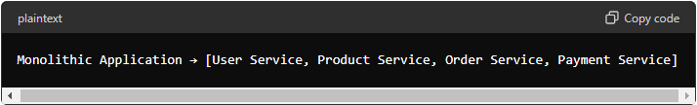

* **Detailed Example: E-Commerce Platform**
  + **Aggregator:** The homepage service calls user service, product service, and order service, aggregates the data, and sends a single response to the client.

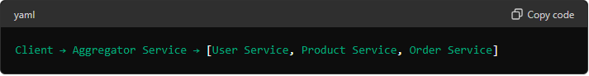

* + **API Gateway:** The mobile app makes requests to the API Gateway, which routes requests to appropriate microservices and handles cross-cutting concerns.

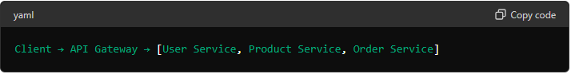

* + **Chained of Responsibility:** The order processing involves multiple steps handled by different services in a sequence.

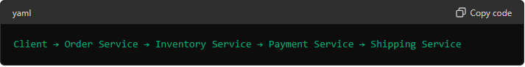

* + **Asynchronous Messaging:** Order events are published to a message queue, and various services consume and process these events.

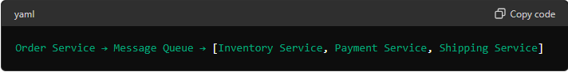

* + **Database Design Patterns:** Each service has its own database, ensuring data isolation and independence.

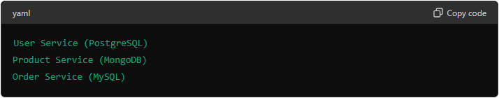

* + **Event Sourcing:** All changes to the order state are stored as events, allowing reconstruction of the order history.

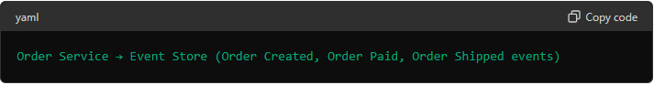

* + **Command Query Responsibility Segregator (CQRS):** Commands for creating and updating orders are handled by the write model, while queries for retrieving order details are handled by the read model.

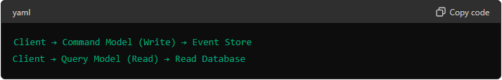

* + **Circuit Breaker:** The order service uses a circuit breaker to prevent repeated calls to a failing payment service, ensuring system stability.

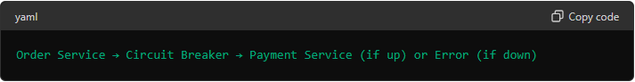

* + **Decomposition Design Patterns:** The monolithic e-commerce application is decomposed into microservices based on business capabilities.

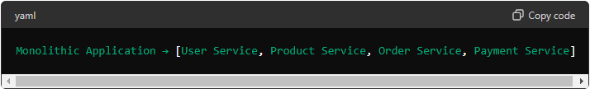

Microservices design patterns provide solutions to common architectural challenges, ensuring that systems built using Microservices are scalable, resilient, and maintainable. Understanding and implementing these patterns effectively can significantly enhance the performance and reliability of modern software systems.